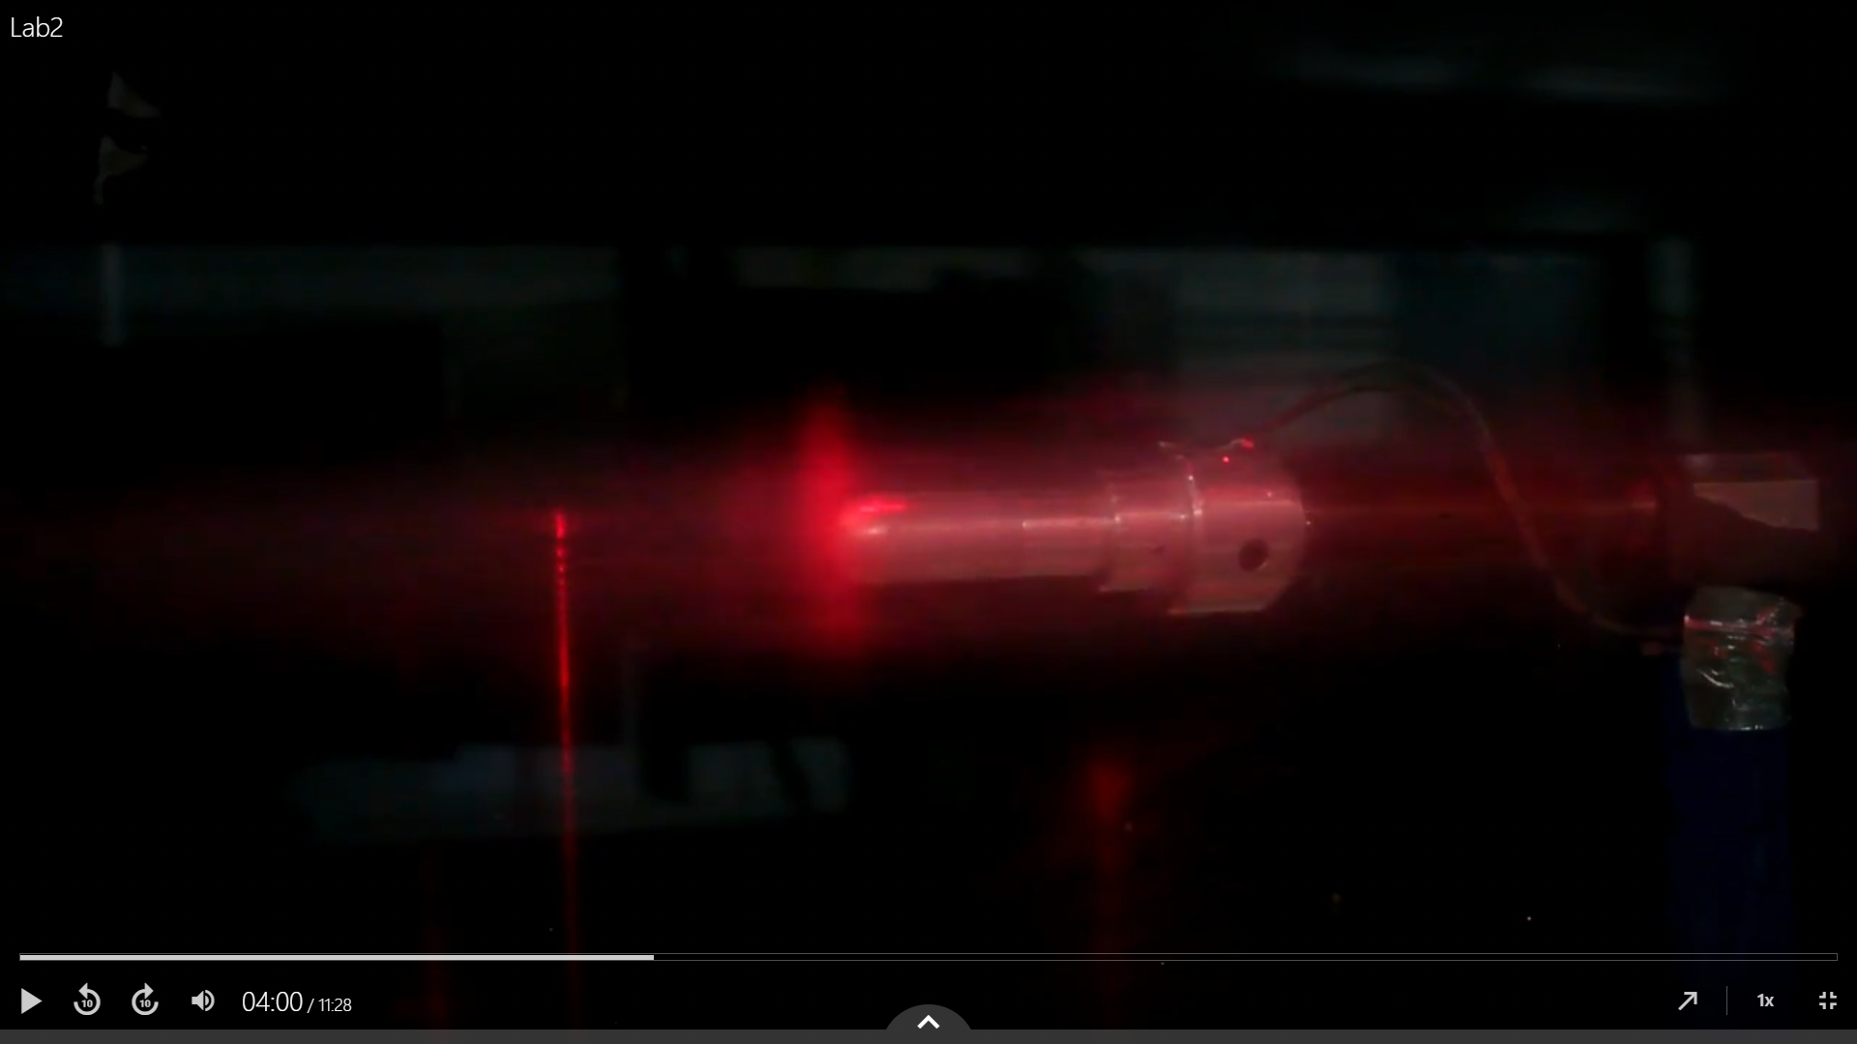

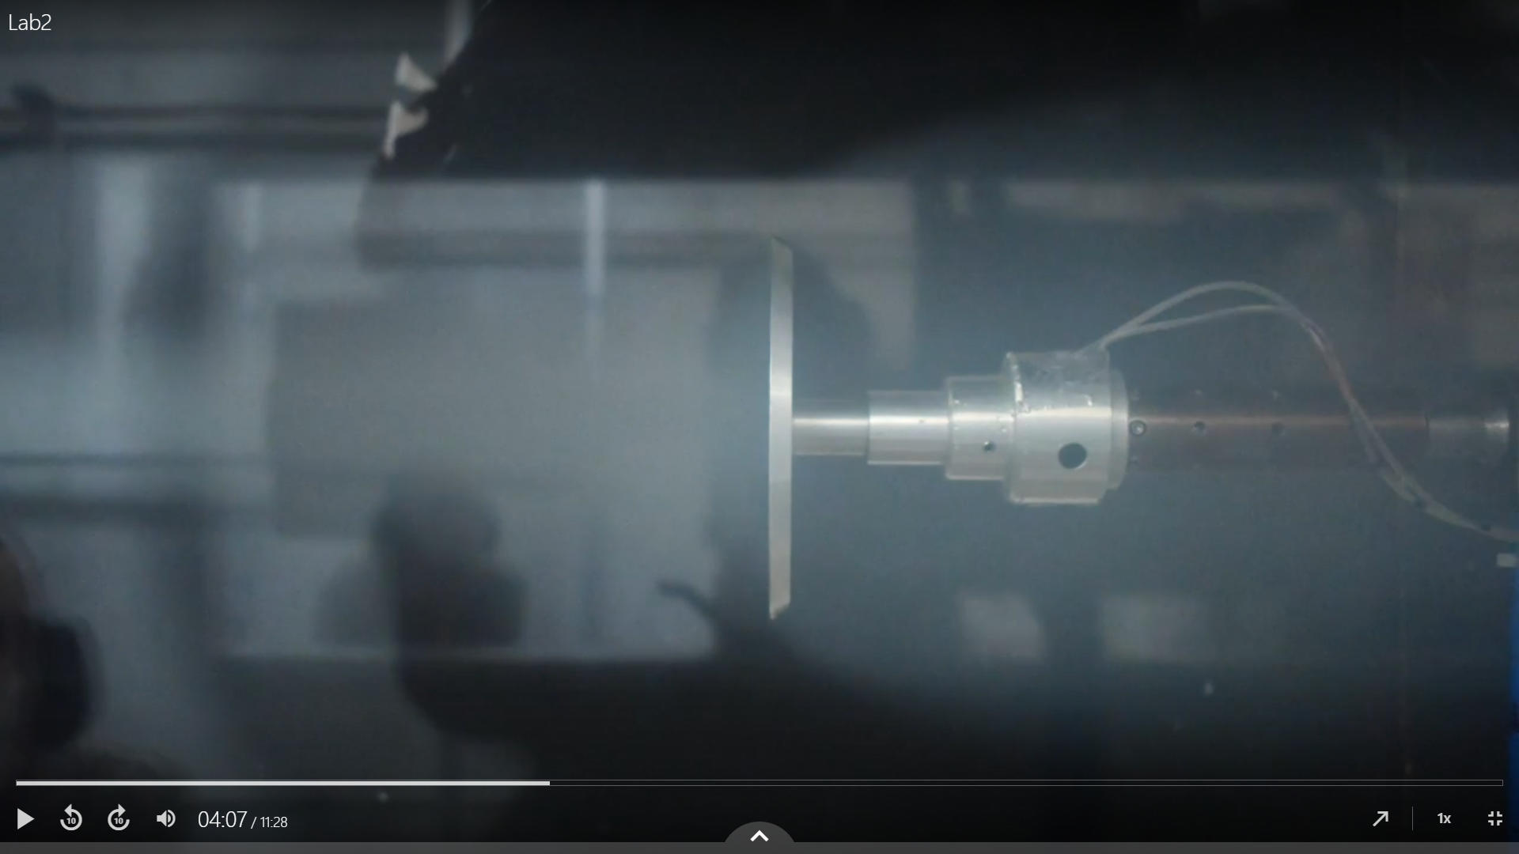

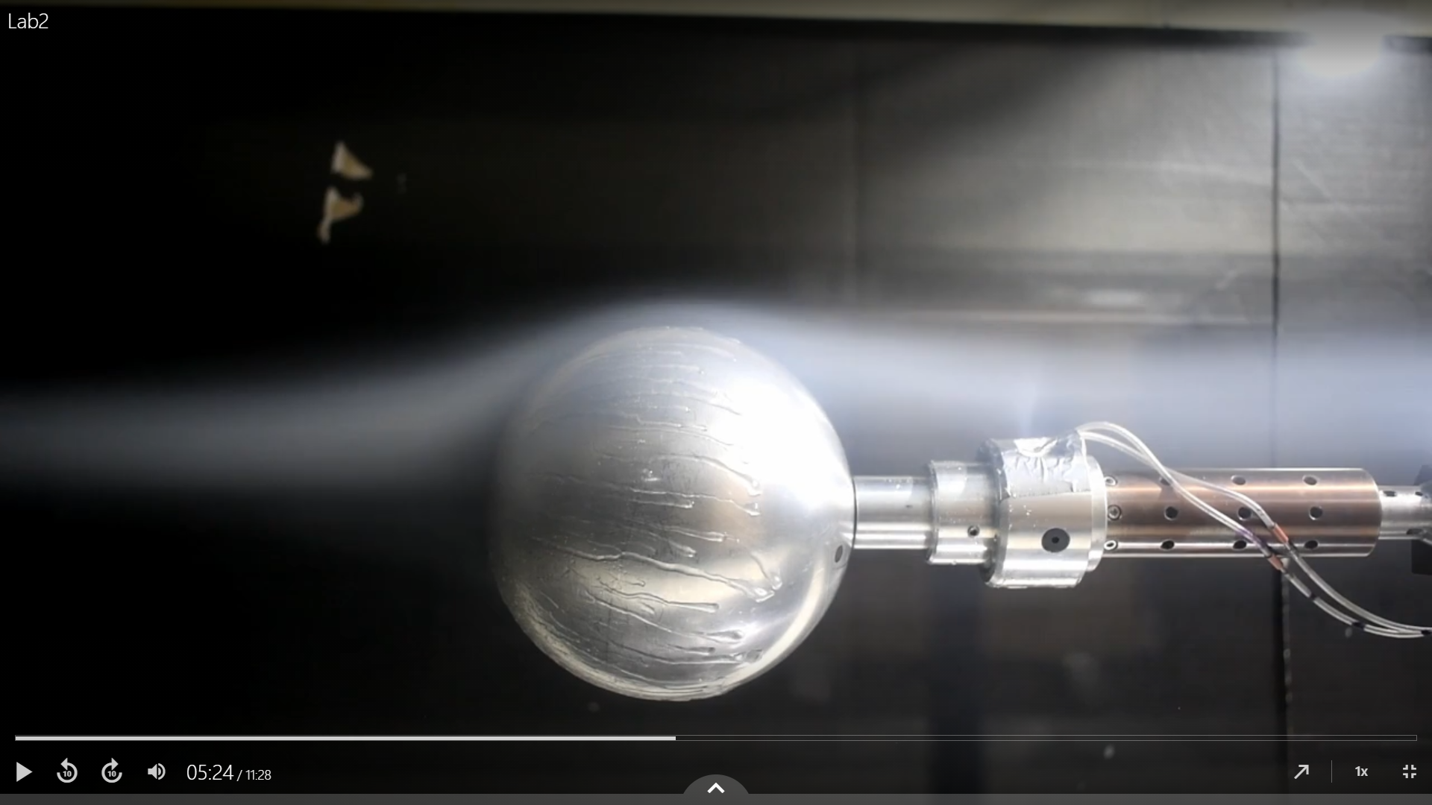

Figure q=5psf, Re=200,000

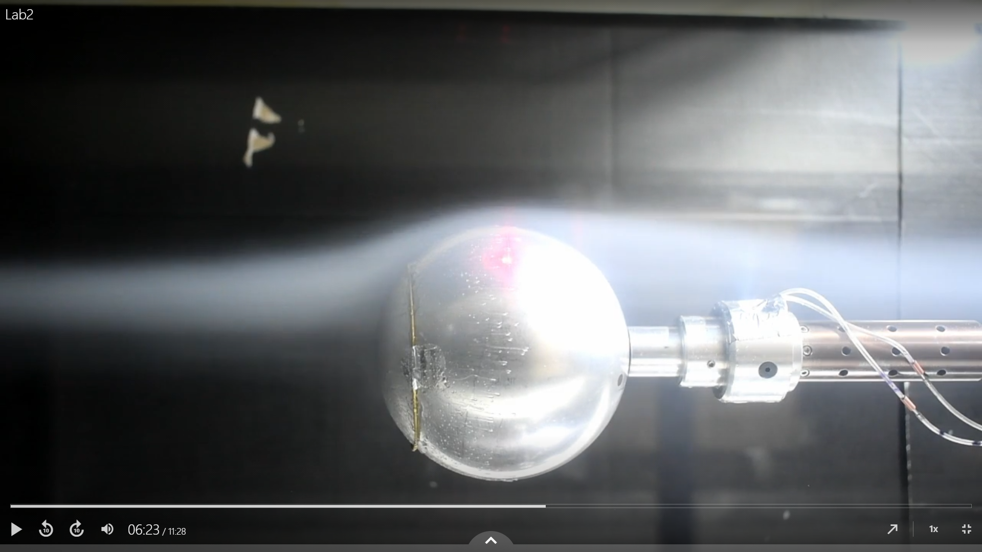

Figure

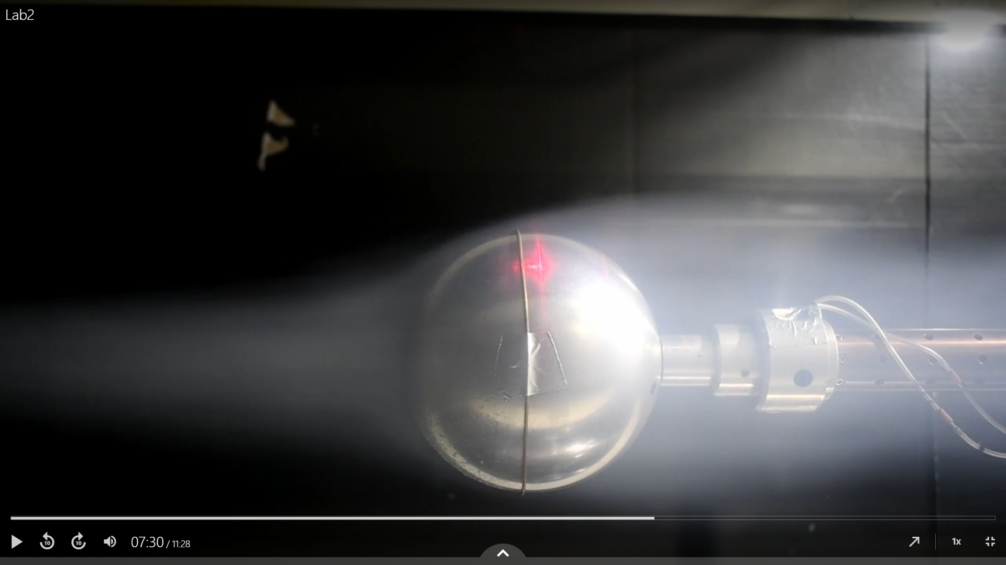

Figure q=2psf, Re<200,000 Vortex shedding occurred

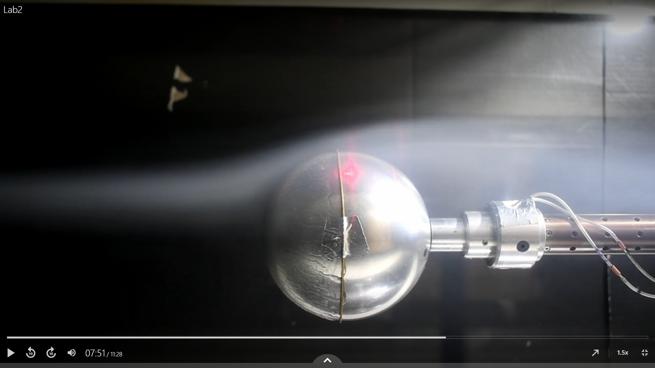

Figure q=5psf, vortex shedding is no longer visable.

Analysis questions

1.The correction for qind is -9.36e-06, for all tests, the variance is of the magnitude 10-19 in all cases and is essentially zero.

The force and deltaq corrections for all tests must be considered separately for each case

The qind, deltaq and force data was corrected by subtracting the average zero-wind condition baseline from the data.

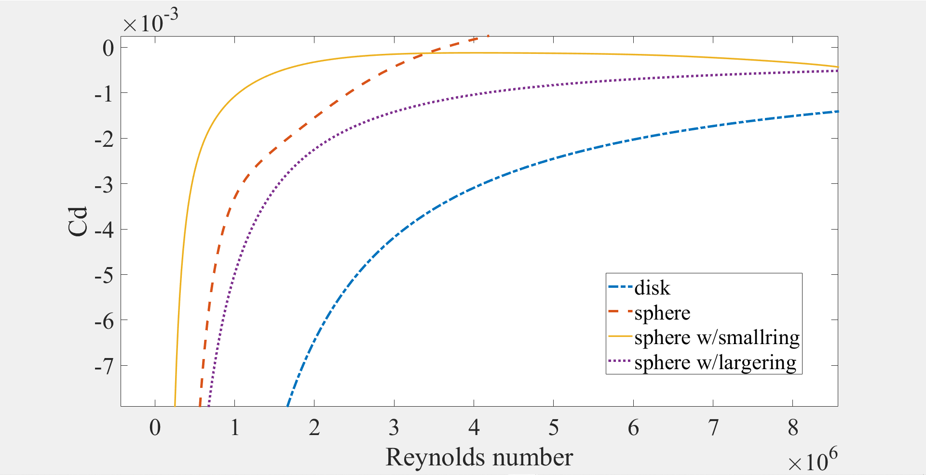

2. From the equation of the Reynolds number the definition of dynamic pressure

$${ R}_{E}=\frac{\sqrt{2ρ}d}{µ}\sqrt{q}$$

If the density and absolute viscosity of air during the test are constant, then RE becomes a function of dynamic pressure. Although temperature was measured during the tests, the pressure was only measured at three times given in the lab notes. For this reason, the average density is calculated from the information in the lab notes instead of from the regular lab data.

From the matlab script avg_density.m

ρ = [0.00232662 0.00232909 0.00232438] (slug/ft^3)

ρavg = 0.0023267 (slug/ft^3) w/ variance of 2.3523e-06

Tavg = 19.2 °C w/ variance of 0.3, the variance of T from the test data is 0.5776

with a low of 17.2749 and a high of 19.9271 °C

µ = 0.3778e-6 (lb*s/ft^2) ± 0.1%

At 19.2 degrees Celsius, the absolute viscosity of air is 0.3778e-6 (lb*s/ft^2) ± 0.1% from engineeringtoolbox.com.

<https://www.engineeringtoolbox.com/air-absolute-kinematic-viscosity-d_601.html?vA=19.2&units=C#>

d = 0.416667 ft

3. Cd can be expressed in terms of D and Re

$$C_{D}=\frac{8ρ}{πμ^{2}} \frac{D}{R_{E}^{2}}$$

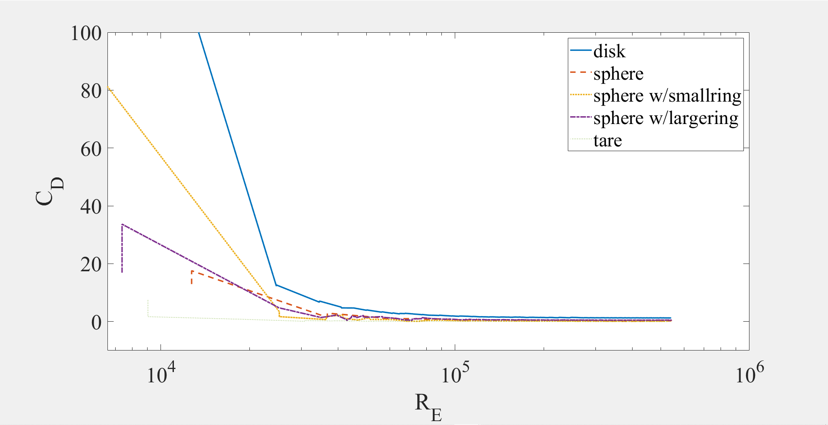

Cd vs Re on a log(10) scale for Re.

Critical Reynolds numbers appear to be

Re_tare = ~30866

Re_disk= ~24693

Re_sphere= ~36780

Re_smallring= ~25260

Re_largering= ~ 39900

5. Cp can be written in terms of deltaP and Re as follows

$$C_{P,(f-r)}=\frac{2d^{2}ρ}{μ^{2}} \frac{∆P}{R_{E}^{2}}$$